Chapter 19, Problem 66.

In the two-port of Fig.19.113, let y₁₂ = y₂₁ = 0, y₁₁ = 2 mS, and y₂₂ = 10 mS. Find V_{o}/V_{s}.

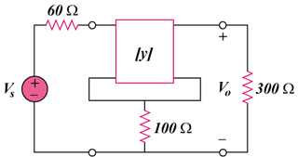

Figure 19.113
For Prob. 19.66.

